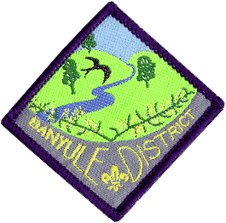
Banyule District Cubs
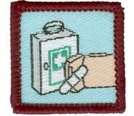
Level 2 First Aid Course

Saturday 25 May & Sunday 26 May
1st Ivanhoe Scout Hall
49 Hawker St Ivanhoe

Cost: $25 per Cub (includes 2 lunches and 1 dinner)
Eligibility: Cubs who haven’t done the course and are due to go up to Scouts
by end of June 2020.
Wear: Full uniform
Saturday: Cubs need to arrive for an 11-00am start on Saturday.
Cubs need to be signed in & parents to leave a contact number.
Cubs need to be picked up at 7-30pm Saturday
Sunday: Cubs need to arrive for a 9-30am start on Sunday.
All Cubs will be finished by 2pm Sunday

All Cubs MUST bring a small personal First Aid kit (should be put together by the Cub). See your Akela for details about this. It should be fitted in a small container.

The Saturday will consist of training in a wide range of aspects of First Aid, along with breaks for some fun. There is one more training session on Sunday (First Aid kits) before we get into the testing session. In addition to a written multiple choice test, Cubs will be paired up and tested across a number of different scenarios where they will treat the ‘victim’ for the problems they find.

If your child needs to be absent for a small part of the weekend could you please write on the form the time they will be missing.

We also need to know about any special dietary requirements.
- Please advise your Leader ASAP by email, to help with catering.

Return to your Akela by, at the latest, Friday 17th May
Banyule District Cub First Aid Weekend:

Cub Name.............................................. Pack.....................................
Dietary requirements..........................................................................
Will be missing from the Course? (When?).......................................................
Enclosed $25
Signed..................................... Phone No...................................

